📄 PROJECT DOCUMENT

AS-IS Process Analysis

Document Control
Document Name | AS-IS Process Analysis
Project Name | ConnectSphere Trust & Safety Operations Intelligence
Phase | Requirement Analysis
Version | 1.1
Prepared By | Tushar Mehta – Business Analyst
Reviewed By | Operations Manager, WFM Manager, QA Manager, Finance Manager, Product Owner
Date | 09 July 2026
Status | Draft

1. Purpose
The purpose of this document is to map and analyze the current state (AS-IS) of the Trust & Safety operational workflows, including Workforce Management (WFM), Quality Assurance (QA), and Finance billing processes. This baseline will be used to identify systemic bottlenecks and inform the design of the TO-BE centralized analytics solution.

2. Scope

2.1 In Scope
- Content Moderation, Account Takeover (ATO), and AI Data Annotation workflows.
- Workforce capacity planning, scheduling, and real-time monitoring.
- Internal QA, Client QA, coaching feedback loops, and appeals.
- Weekly finance billing reconciliation and revenue realization.
- Current end-to-end reporting and data consolidation processes.

2.2 Out of Scope
- Modifications to the primary ConnectSphere client moderation UI.
- Upstream client engineering or data generation systems.

3. Stakeholders
Name / Role | Department | Process Area
Director – Trust & Safety | Operations | Executive Oversight
Operations Manager | Trust & Safety | Core Moderation & ATO
Workforce Planning Manager | WFM | Capacity & Scheduling
QA Manager | Quality Assurance | Auditing & Calibration
Finance Manager | Finance | Invoicing & Revenue
Product Owner | Product | Feature Approval & Strategy

4. High-Level Process Flow
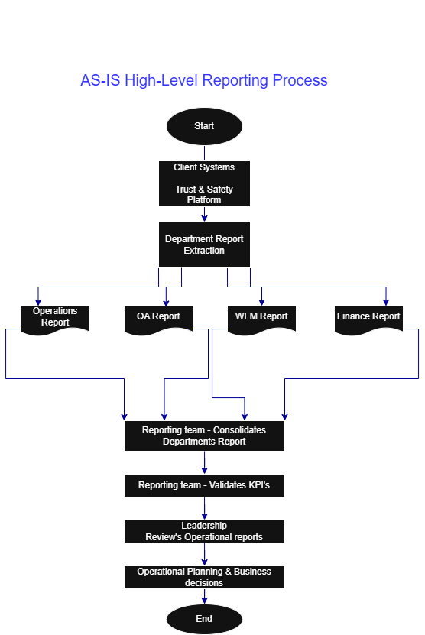

4.1 Operations Workflow
- Users upload content, or automated AI models flag potential violations.
- Content routes to specialized queues.
- Moderators review content and close cases.
- Managers manually export volume, SLA, and backlog data.

4.2 Workforce Management (WFM) Workflow
- WFM receives expected workload and calculates headcount.
- Schedules are generated across shifts.
- Intraday monitoring occurs manually.
- WFM validates billable hours at week-end.

4.3 QA & Finance Workflows
- QA manually samples and audits cases; scores are logged in Excel.
- Finance cross-checks contract rules against WFM exports.
- Billable effort is manually calculated for invoicing.

5. AS-IS Reporting Process Inventory
Step No. | Process Step | Owner | Input | Output | Method
1 | Client moderation platform generates operational data | Client System | User activity | Raw operational data | Automated
2 | Operations exports operational reports | Operations | Client reports | Operations report | Manual
3 | WFM exports workforce reports | WFM | Workforce data | Workforce report | Manual
4 | QA exports quality reports | QA | Audit data | QA report | Manual
5 | Finance exports billing reports | Finance | Billing data | Billing report | Manual
6 | Business Analyst consolidates all reports in Excel | Business Analyst | Department reports | Consolidated dataset | Manual
7 | Business Analyst validates KPI calculations | Business Analyst | Consolidated dataset | Validated KPI report | Manual
8 | Leadership reviews reports | Leadership | KPI report | Business insights | Manual
9 | Leadership takes operational decisions | Leadership | Business insights | Action items | Manual
10 | Feedback Loop & Archival | Business Analyst | Action items / KPI report | Archived weekly report & adjustments | Manual

6. Step-by-Step Pain Points Analysis
Process Step | Pain Point / Bottleneck | Business Impact
Operations Export | Manual report export | Time-consuming; susceptible to system timeouts and data limits.
WFM Export | Separate workforce reports | Lacks correlation with live moderation queues; delays intraday adjustments.
QA Export | Different report format | Requires heavy data transformation and data cleansing before merging.
Finance Export | Manual billing validation | High risk of revenue leakage due to incorrect AUX mapping.
Excel Consolidation | Time consuming and error prone | Formulas and macros break easily; security risks with offline files.
KPI Validation | Different KPI definitions | Misalignment among leadership; inconsistent reporting narratives.
Leadership Review | No single dashboard | Static views only; inability to drill down into historical trends.
Decision Making | Delayed due to fragmented reporting | Reactive instead of proactive decision making; lost optimization opportunities.

7. Current State Assessment
The current Trust & Safety reporting process relies heavily on manual extraction, validation, and consolidation of operational reports from multiple departments.
Key observations include:
- Reporting is decentralized across Operations, WFM, QA, and Finance.
- Data consolidation is performed manually using Excel.
- KPI definitions are inconsistent across departments.
- Leadership lacks a centralized reporting platform.
- Report preparation requires significant manual effort.
- Cross-functional analysis is difficult because data exists in separate files.
- Decision-making is delayed due to fragmented reporting.

8. Process Metrics
Metric | Current State
Report Preparation Time | ~3 Hours
Reports Consolidated | 4 Department Reports
Reporting Frequency | Weekly
Dashboard Availability | No
Manual Activities | High
KPI Standardization | No
Historical Analysis | Limited
Cross-functional Visibility | Low

9. Assumptions & Constraints
- The workflows described reflect actual day-to-day operations.
- Client systems will continue to generate required data in accessible export formats.
- API integration with the client system is currently restricted by security protocols.

10. Cross-Functional Swimlane Diagram
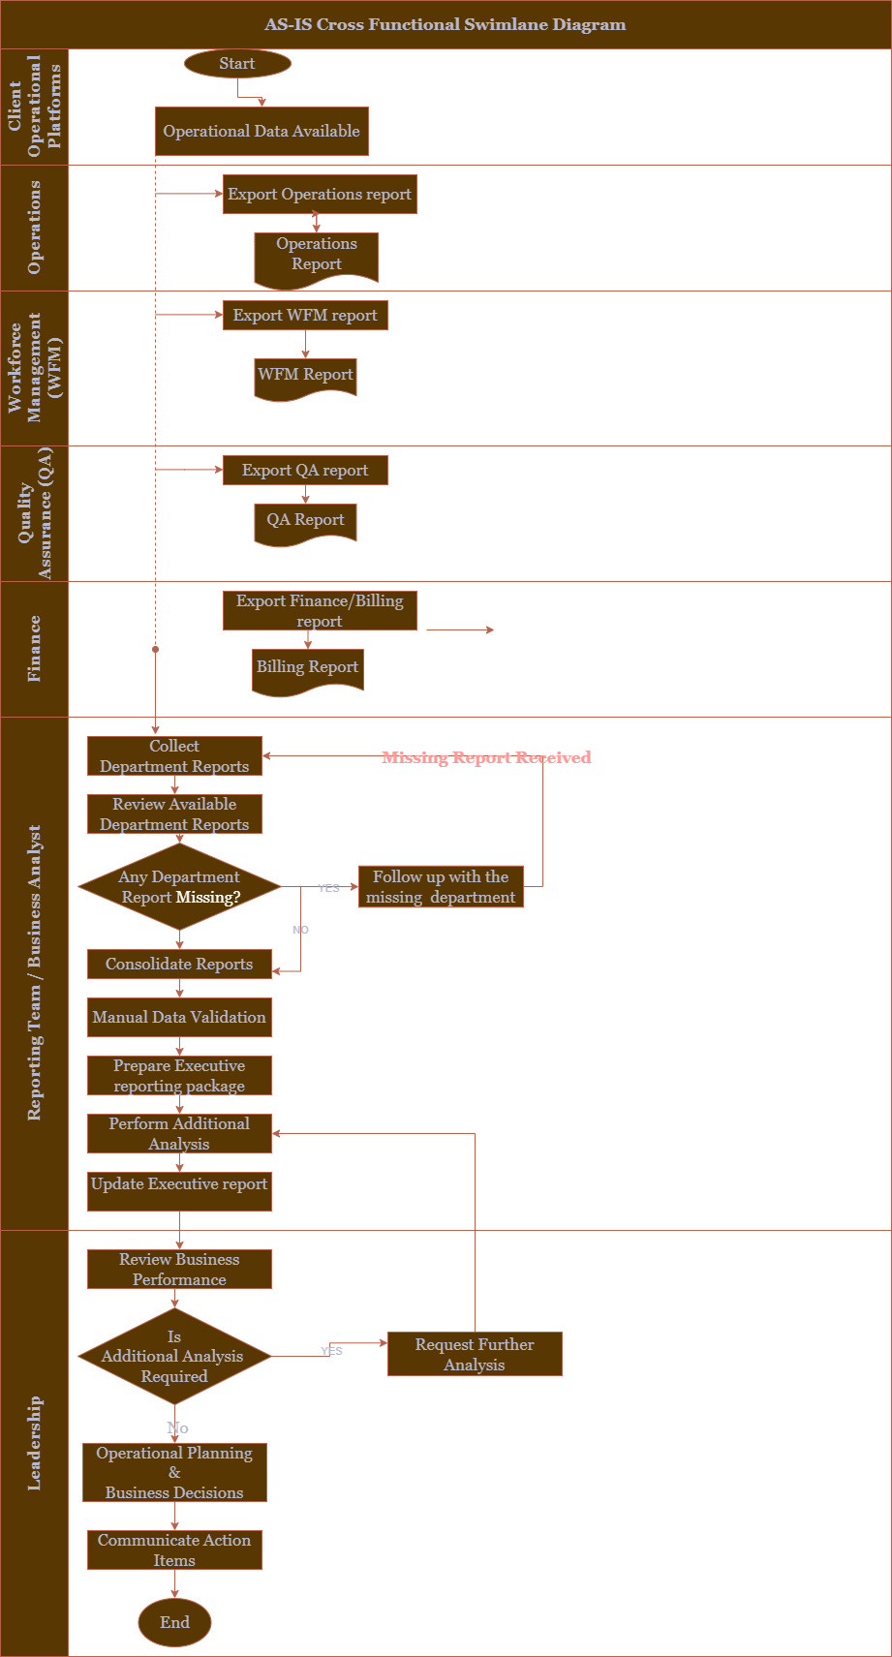

11. Improvement Opportunities
- Centralized reporting platform
- Automated data consolidation
- Standardized KPI calculations
- Integrated dashboards
- Automated billing analytics
- Cross-functional reporting
- Executive dashboard
- Historical trend analytics

